msansom@westnet.com.au
Jan 18 (10 days ago)
to me
22 Goola Ave
Kahibah
N.S.W. 2290
02 49430968
msansom@westnet.com.au
18-1-2015

Dear Sir/Madam
These additional attachments illustrate what I meant by coal on the end platforms of coal hoppers.
Unfortunately I was unable to successfully photograph coal in the bogies although I did see this on a number of wagons.
Thanking you for your time.
Yours faithfully:
Peter Sansom

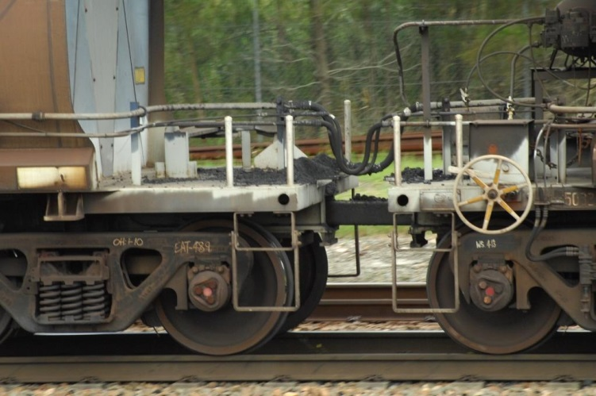

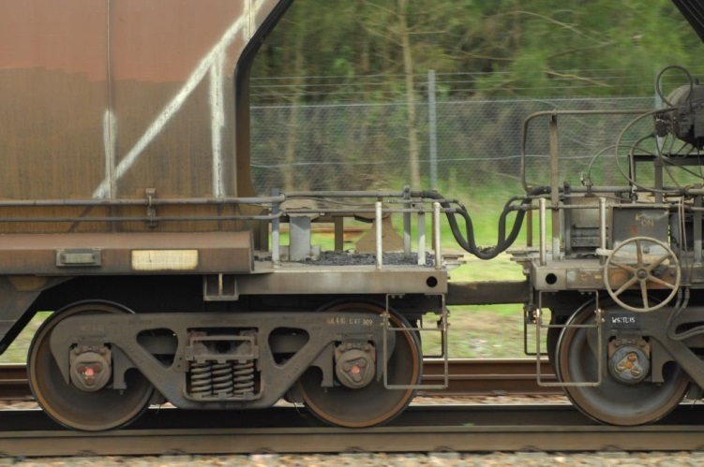

CoalTrains Review <coaltrains.review@chiefscientist.nsw.gov.au>

Submission regarding dust from coal trains
3 messages

msansom@westnet.com.au <msansom@westnet.com.au> Fri, Jan 15, 2016 at 11:11 AM
To: Coal dust Submission <coaltrains.review@chiefscientist.nsw.gov.au>
22 Goola Ave
Kahibah
N.S.W. 2290
02 49430968
msansom@westnet.com.au
15-1-2016

Dear Sir
I wish to make the following submission regarding dust emissions from coal trains in the Hunter Region. Until I retired in June 2014, I was a locomotive engine man with more than thirty five years experience. During that time I worked all manner of trains. However, the last twelve years of my career were spent driving coal trains.
It may be worth pointing out that while some particulates may be invisible to the naked eye during daylight, the dust can be seen more clearly at night in the beam of the locomotive headlight.
With this in mind, the source of dust would be from the following places.
The track would be the most common source of dust, particularly during dry weather and after track work.
Sand from the sand pipes from the locomotives would be another source. The sand is used to aid adhesion between the driving wheels and the rails.
One source of coal dust would be from coal that has been spilt on the end platforms on the wagons when they are being loaded.
Coal is also caught in the bogie components as coal is being discharged from the hoppers during unloading operations at Port Waratah and Kooragang. I have seen the coal build up in the bin above rail level to the extent it gets caught on the bolsters, bogie side frames and brake rigging. This would explain why coal dust is see between the rails on the down coal lines.
Despite what some are saying, coal dust does not come from the hoppers. The coal is too wet.
When the Environmental Protection Authority said that most dust from passing trains would have come the track, they would have been right. I do not believe that fitting covers to coal hoppers will achieve anything.
The true source of dust from coal trains needs to be understood or a lot of time, effort and money will be wasted.Yours faithfully:
Peter Sansom

3 attachments
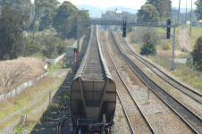
P.S. 1-9-14 Tarro 107.JPG
5357K

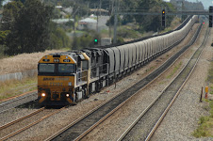
P.S. 1-9-14 Tarro 152.JPG
6577K
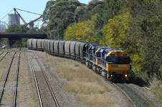
PS 9-9-2014 056.JPG
9105K

CoalTrains Review <coaltrains.review@chiefscientist.nsw.gov.au> Fri, Jan 15, 2016 at 2:22 PM
To: msansom@westnet.com.au
Dear Mr Bowman,

Thank you very much for your submission to the Review, this information will be used in developing the Final Report which is due to be released at the end of March 2016. Your submission will be placed on the NSW Chief Scientist and Engineers website at http://www.chiefscientist.nsw.gov.au/reports/review-of-rail-coal-dust-emissions/public-submissions-rail-coal-dust-review. Could you please indicate whether you took the photos attached to your submission and if so, are you comfortable with us adding them to the website?

Please don't hesitate to contact us if you have any further submissions, questions or comments

Kind Regards

Justin Walker
Senior Project Officer, Office of the NSW Chief Scientist and Engineer

[Quoted text hidden]
--
NSW Department of Industry | Office of the NSW Chief Scientist & Engineer
W: www.chiefscientist.nsw.gov.au

msansom@westnet.com.au <msansom@westnet.com.au> Fri, Jan 15, 2016 at 5:14 PM
To: CoalTrains Review <coaltrains.review@chiefscientist.nsw.gov.au>
22 Goola Ave
Kahibah
N.S.W. 2290
02 49430968
msansom@westnet.com.au
15-1-2015
Dear Sir/Madam
Yes I took the photos that are attached to my submission and you are welcome to add them to the web site.

Yours faithfully:
Peter Sansom
----- Original Message -----
From:
"CoalTrains Review" <coaltrains.review@chiefscientist.nsw.gov.au>

To:
<msansom@westnet.com.au>
Cc:

Sent:
Fri, 15 Jan 2016 14:22:22 +1100
Subject:
Re: Submission regarding dust from coal trains
[Quoted text hidden]

This message is intended for the addressee named and may contain confidential information. If you are not the intended recipient, please delete it and notify the sender. Views expressed in this message are those of the individual sender, and are not necessarily the views of their organisation.

